To search words within a selected folder, you can click “cs” , then select Resource in active editor:

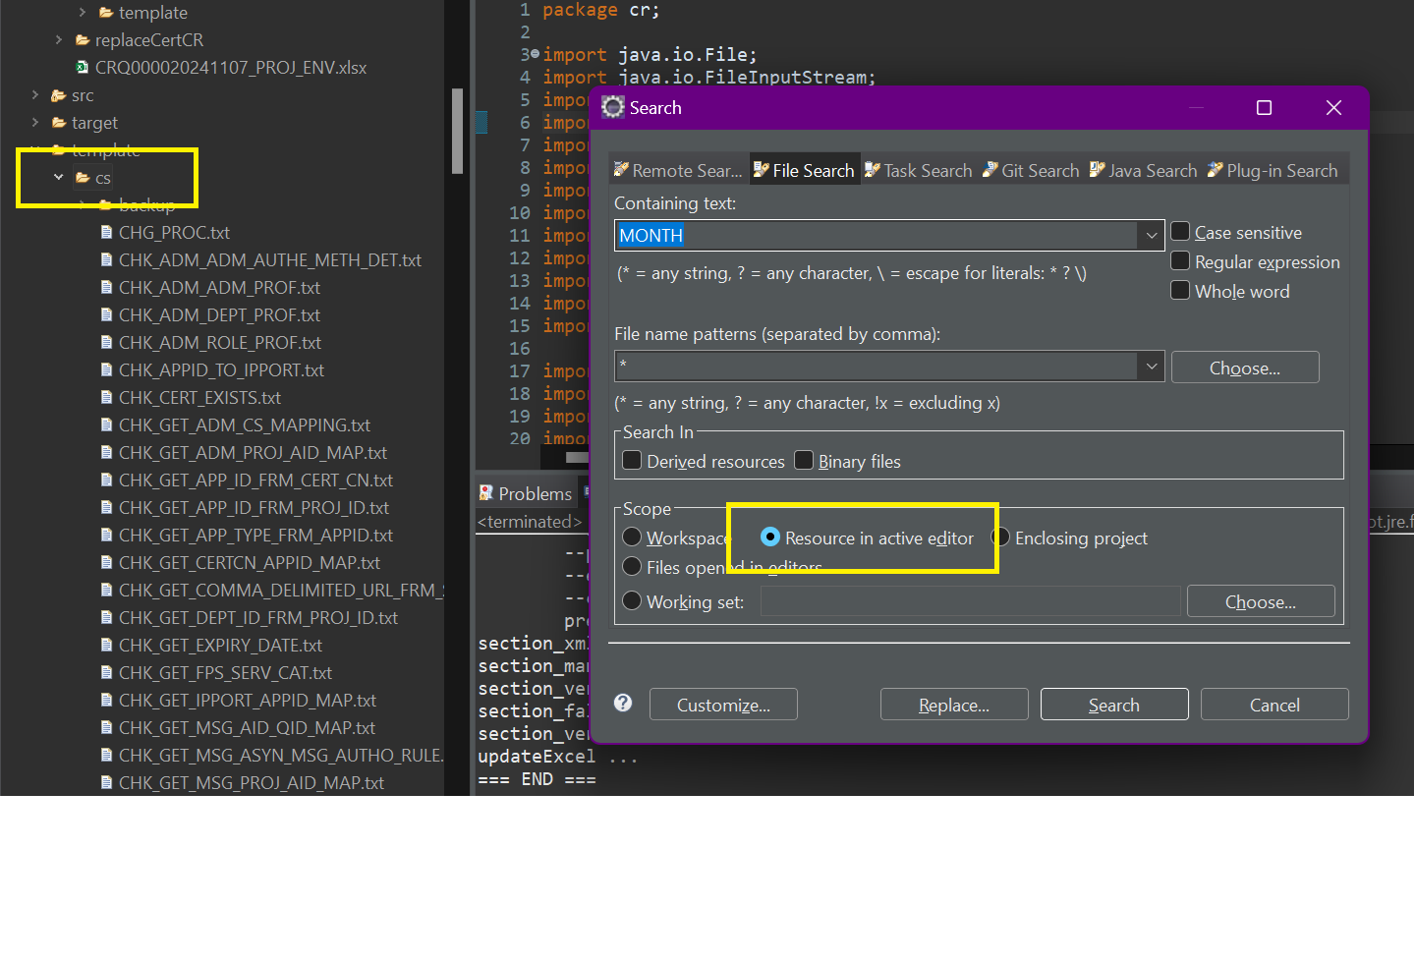

You can also choose workspace as whole project for search

Files open in an editor